**WEB PROGRAMING PRACTICUM REPORT**

**MODULE 2**

**HTML CONTINUED**



**CREATED BY :**

**KURNIAWAN BAGASKARA**

**L200214253**

**INFORMATICS STUDY PROGRAM**

**FACULTY OF COMMUNICATION AND INFORMATION SCIENCE**

**MUHAMMADIYAH SURAKARTA UNIVERSITY**

TASK

1. Write an HTML script to create a running image where the image is a hyperlink to the address www.yahoo.com. (image size 100 x 50 pixels, and target hyperlinks in the same window)

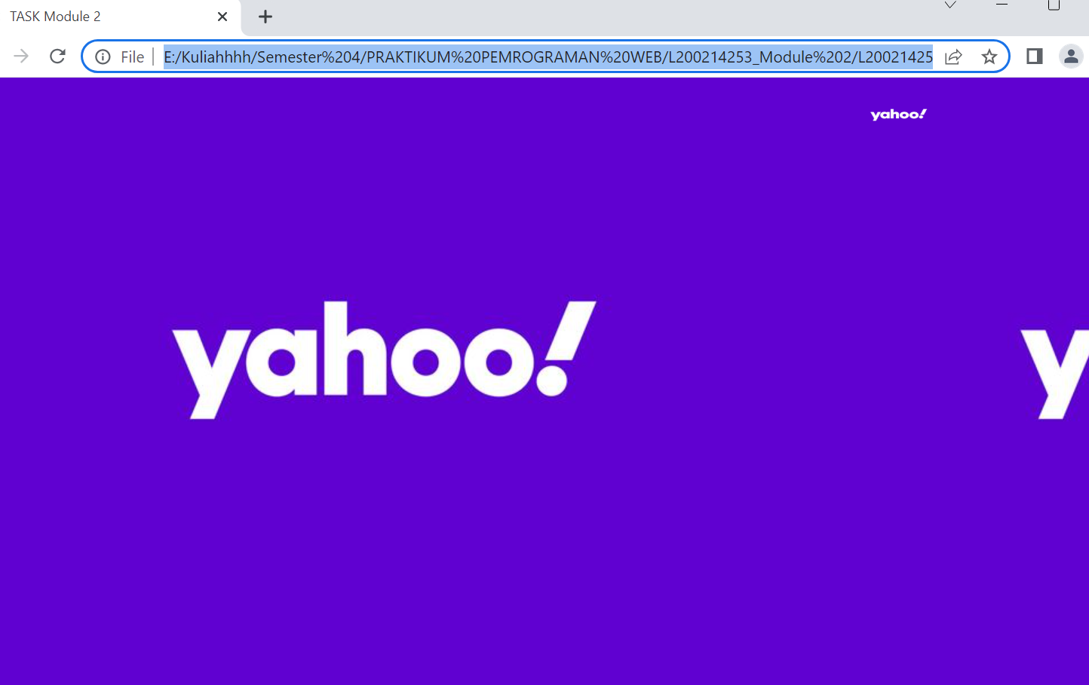

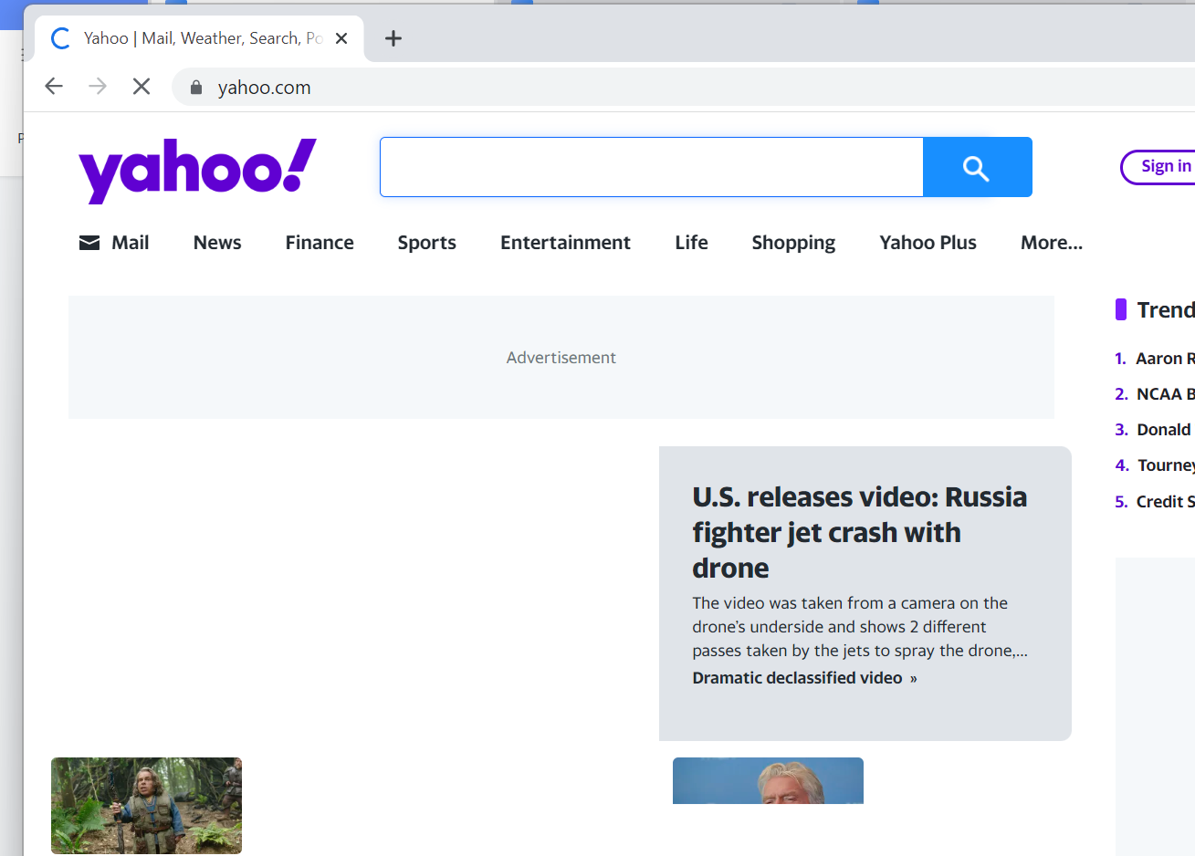

1. .Explain the function of the following tags and attributes:

|  |  |  |
| --- | --- | --- |
| **NO** | **Tag/Atribut** | **Function** |
| 1 | <a href=’halaman2.html’> | Used when the user clicks on the word page 2 then the user will be directed to another html page, namely on a page called page2.html  Or it can be called a hyperlink tag to page 2 |
| 2 | <a href=’http:// www.google.com’> | Used when the user clicks, the user will be directed to the Google page  Or it can be called a hyperlink to the Google window |
| 3 | <a href=’referensi’> | Used when the user clicks, the user will be directed to a page named reference  Or it can be called a hyperlink to the reference window |
| 4 | Target=’_blank’ | Used to make links open in new windows |
| 5 | <INPUT type=’checkbox’> | Used to provide an input command that has the type of a checkbox on an html page |
| 6 | Name=’cekSing’ | Give it a name in the form of CekSing |
| 7 | <INPUT type=’text’> | Used to provide input commands of type text on html pages |
| 8 | Id=’txtKota’ | Used to provide an ID named txtKota |
| 9 | Maxlenght=’20’ | The length or maximum of text, numbers or symbols that can be entered is limited to 20 digits |
| 10 | <TEXTAREA></TEXTAREA> | A tag used to input a text area |
| 11 | Cols=’20’ | Used to provide a column size of 20 |
| 12 | &nbsp; | It is a non-breaking space function |
| 13 | <marquee>…</marquee> | Used to make images/text move in a direction from right to left |
| 14 | <blink>…</blink> | Make writing twinkle |